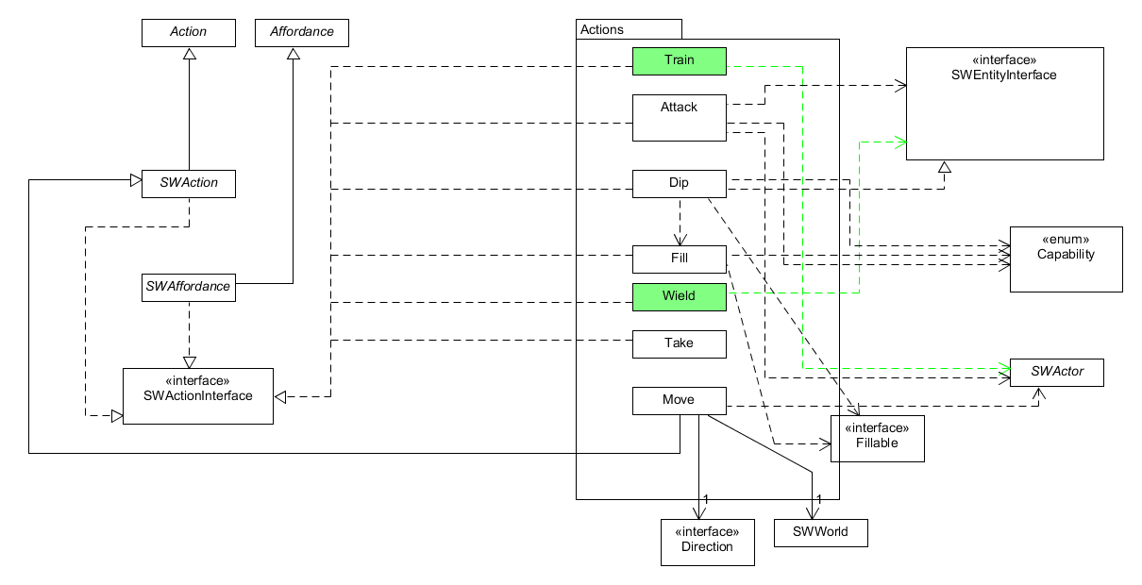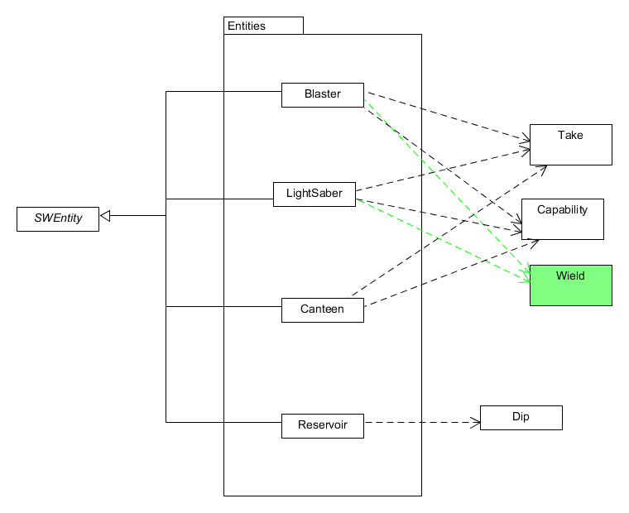

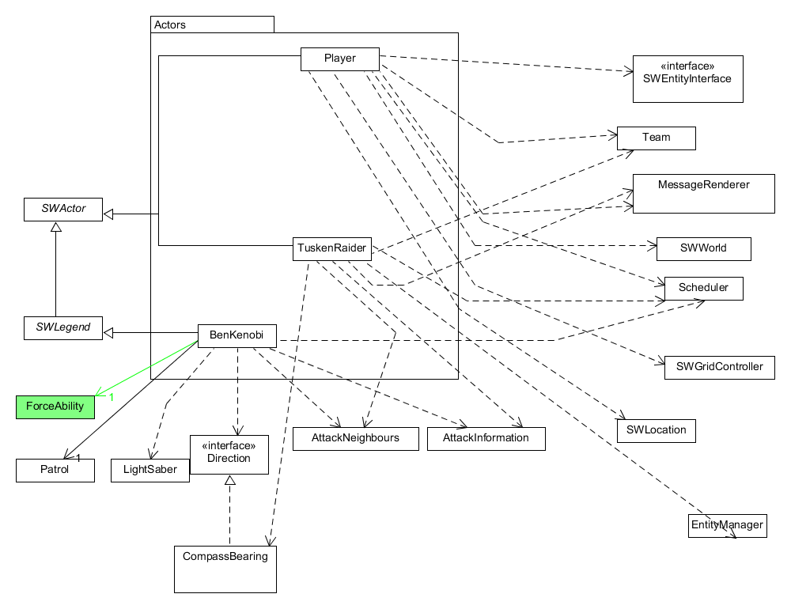

**Force ability**

The following classes will be introduced:

* ForceAbility

ForceAbility will be implemented as a behaviour similar to the way Patrol is currently implemented in relation to SWActors. It will encapsulate functionality and store data that lets SWActors utilize and interact with the Force.  
Where required, SWActors will have one instance of ForceAbility.

Implementing ForceAbility as a behaviour will allow for future extensibility. If additional interactions or abilities that relate to the force are introduced, they can be incorporated into ForceAbility.

**Lightsabres**

The following classes will be introduced:

* Wield

Wield will extend the SWAction class and will encapsulate functionality relating to SWActors equipping entities (such as a lightsabre). Following the usage of Wield, the SWActor will have the applicable SWEntity equipped to attack with as long as the SWActor met the minimum requirements for that SWEntity.

Implementing Wield in this way not only solves the requirement for lightsabres but lets us handle ‘stat requirements’ for other possible SWEntities in a generic way.

**Ben Kenobi**

The following classes will be introduced:

* Train

Train will extend the SWAction class and facilitate a SWActor training another SWActor who is at the same location. Following the usage of Train, the other SWActor will have the required force ability to wield a lightsabre.

Implementing Train allows Ben the ability to train Luke, whilst also allowing other potential SWActors to use Train if required in the future.